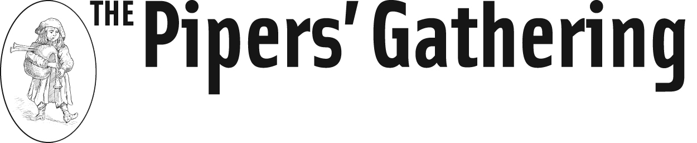

“North America’s most comprehensive alternative bagpipe event”

August 18 – 20, 2017
Wisdom House, Litchfield, CT

Instructors include
Ian Kinnear & Chris Layer - Scottish smallpipes
Patrick D’Arcy & Michael Stribling - Uilleann pipes
EJ Jones - Border pipes
Chris Ormston - Northumbrian smallpipes
Chris Gray – Pipes, whistle
John Skelton - Flute, bombard
Frances Cunningham - Bouzouki

Public Concerts featuring instructors on August 19 & 20, 2017

Further information on all events at:
www.pipersgathering.org

“Like” The Pipers’ Gathering on Facebook for updates, information and videos

